COMHAIRLE CONTAE CHORCAÍ

**_____________________________________________________________________**

**Minutes of Proceedings at Meeting of Cork County Council held in the Council Chamber, County Hall, Cork on 9th September, 2019**

**I LATHAIR**

Comhairleoir, Cristóir Ó Suilleabháin Méara Chontae

Uí Chochláin G, Ó Colmáin, Ó Murchú C, Ó Suilleabháin S, Uí Shuilleabháin M, Ó Donnabháin, Ó Coileáin D, Uí Mhurchú Cáit, Mac Íomhair – Uí Chearnaigh, Mac Craith, Ui Daltún, Uí Bhuachalla, Ó Conchubair L, Daltún Ó Suilleabháin, Ó Suilleabháin P, Barra, Sheppard, Rasmussen, Ó Conchubair S, Ó Conchubair A, MacCarthaigh N, Ó Floinn, Ui Bhriain, Ó Laoghaire, Dawson, De Róiste, Ó Muineacháin B, Ó Dubhghaill, Ó Sé. JP, Ó Murchú Gearóid, Críod, Ní Mhuineacháin G, Ó Luanaigh, Ó Cochláin M, Uí Loinsigh, Ó Luasa, Ó hAodha Padraig, Ó Murchú Gerard, Ó Cinnéide, Ó Madaoin, Ó Sé. T, Léineacháin Ui Foghlú, O Coileáin N, Ó Héigeartaigh, Ó Conchubair Séamus, Uí Thuama, MacCarthaigh S, Mac Uaid, Ó Cearbhaill, Ó Muirthile, Uí Chaochlaoich, Ó hAodha Pól.

**PRESENT**

Councillor, Christopher O’Sullivan, County Mayor presided.

Councillor Coughlan G, Coleman, Murphy Kevin, O’Sullivan J, O’Sullivan M, O’Donovan, Collins D, Murphy Katie, Cairns, McGrath, D’Alton, Buckley, O’Connor L, Dalton O’Sullivan, O’Sullivan P, Barry, Sheppard, Rasmussen, O’Connor S, O’Connor A, McCarthy N, O’Flynn, O’Brien, O’Leary, Dawson, Roche, Moynihan B, Doyle, O’Shea J.P, Murphy Gerard, Creed, Moynihan G, Looney, Coughlan M, Lynch, Lucey, Hayes Pat, Murphy Gearóid, Kennedy, Madden, O’Shea T, Linehan-Foley, Collins N, Hegarty, O’Connor J, Twomey, McCarthy S, Quaide, Carroll, Hurley, Coakley, Hayes Paul.

Chief Executive, Senior Executive Officer, Mr. Michael Lynch Director of Planning.

**CONFIRMATION OF MINUTES**

**1/9-1**

Proposed by Councillor Seamus McGrath

Seconded by Councillor Mary Linehan Foley

**RESOLVED:**

“That the minutes of the Annual Meeting held on 22nd July 2019, be confirmed and signed by the Mayor.”

**VOTES OF SYMPATHY**

**2/9-1**

No votes of sympathy recorded.

**STATUTORY BUSINESS**

**Section 183 of the Local Government Act, 2001:**

Members noted the following disposal.

**MUNICIPAL DISTRICT OF FERMOY**

**DISPOSAL OF PROPERTY AT GORTNAHOWN, MITCHELSTOWN** **3(a)/9-1**

In accordance with the provisions of Section 183 of the Local Government Act 2001, the disposal of the property as shown hereunder shall be carried out in accordance with the terms specified in the notice issued to Members dated 9th August, 2019

**SITUATION:** Disposal of property at Gortnahown, Mitchelstown

**AREA:**  0.119 Hectares

**CONSIDERATION:**  €1,500.00

**MUNICIPAL DISTRICT OF BANDON/KINSALE**

**DISPOSAL OF PROPERTY GRANT OF RIGHT-OF-WAY AT TOSTAL TERRACE, UPPER CONVENT HILL, BANDON, CO. CORK** **3(b)/9-1**

In accordance with the provisions of Section 183 of the Local Government Act 2001, the disposal of the property as shown hereunder shall be carried out in accordance with the terms specified in the notice issued to Members dated 9th August, 2019

**SITUATION:** Disposal of property Grant of Right of Way at Tostal Terrace, Upper Convent Hill, Bandon, Co. Cork

**CONSIDERATION:**  €1.00

**MUNICIPAL DISTRICT OF MACROOM**

**DISPOSAL OF LAND AT FLATS, BALLYVOURNEY, CO.CORK** **3(c)/9-1**

In accordance with the provisions of Section 183 of the Local Government Act 2001, the disposal of the property as shown hereunder shall be carried out in accordance with the terms specified in the notice issued to Members dated 9th August, 2019.

**SITUATION:** Disposal of land at Flats, Ballyvourney, Co. Cork

**AREA:**  0.0952 hectares/0.235 acres

**CONSIDERATION:**  €10.00 per annum

**PART 8 MANAGER’S REPORT**

**SECTION 179 OF THE PLANNING & DEVELOPMENT ACT, 2000**

**MUNICIPAL DISTRICT OF EAST CORK**

**4(a) 9-1**

**Members noted the following part 8:**

“Part 8 Development – Construction of a Public Car Park on land adjoining the RC Church on the Killeagh/Mount Uniacke Road (L-79050-0), Killeagh, Co. Cork.”

**Proposed by Councillor James O’Connor**

**Seconded by Councillor Susan McCarthy**

**Resolved:**

“Noting under section 179 of the Planning and Development Act 2000, as amended and part 8, article 81 of the Planning and Development Regulations 2001, as amended. Notice is hereby given that Cork County Council proposes to undertake construction of a Public Car Park on land adjoining the RC Church on the Killeagh/Mount Uniacke Road (L-79050-0), Killeagh, Co. Cork.

**MUNICIPAL DISTRICT OF COBH**

**4(b) 9-1**

**Members noted the following part 8:**

“Part 8 – Proposed Development consisting of Removal of existing playground from car park; installation of new playground adjacent to car park; installation of Multi-Use Games Area and reconfiguration of layout of car park to accommodate proposed market area adjacent to existing Community Centre at Carrigtwohill, Co. Cork.”

**Proposed by Councillor Anthony Barry**

**Seconded by Council Sean O’Connor**

**Resolved:**

“Noting under section 179 of the Planning and Development Act 2000, as amended and part 8, article 81 of the Planning and Development Regulations 2001, as amended. Notice is hereby given that Cork County Council proposes the Development consisting of removal of existing playground from carpark, installation of multi-use games area and reconfiguration of layout of carpark to accommodate proposed market area adjacent to existing community centre at Carrigtwohill, Co. Cork.”

**MUNICIPAL DISTRICT OF WEST CORK**

**5/9-1**

“That this Council would write to Deputy John Halligan T.D. Minister at the Department of Education & skills to highlight the current situation in relation to the lack of school bus tickets and the associated impact on school pupils accessing school bus services in West Cork.”

During this discussion the Members made the following points:

* Members expressed their anger because of inadequate School Transport for pupils
* More funding required to address the lack of resources in Rural and Urban Ireland
* Needs to be addressed as a matter of urgency as families are under pressure
* Policy needs to be changed with a need to cater for the catchment areas
* If not addressed will lead to more cars on the road with traffic congestion
* A simple increase on the size of the buses would be a solution to the problem

Members agreed to write to Minister of Department of Education and Skills to highlight the current situation in the West Cork area.

**CORPORATE POLICY GROUP**

**6/9-1**

Approval of attendance by council Members at conferences on the Conferences List for September 2019.

**Proposed by Councillor Frank O’Flynn**

**Seconded by Marcia D’Alton**

**SECTION 48 OF THE LOCAL GOVERNMENT ACT 2001**

**7/9-1**

Adoption of Draft Strategic Policy Committee Scheme

**Proposed by Councillor Frank O’Flynn**

**Seconded by Councillor Seamus McGrath**

**CORRESPONDENCE FROM GOVERNMENT DEPARTMENTS**

**DEPARTMENT OF HEALTH:**

**8/9-1**

Members noted correspondence dated 16th August 2019 in response to Council’s letter dated 27th June 2019 in relation to Ophthalmology procedures.

During this discussion the member made the following points:

* Members were disappointed with the response
* Misleading information with very little content
* Public commuting 5/6 hours for a 15 minute procedure
* Member expressed their dissatisfaction with the health system
* Concerns over brexit impact

Members agreed to write to the Minister for Health requesting figures on how many ophthalmology procedures were carried out in Belfast in 2017, 2018 and 2019 to date under the Cross Border Health Care Directive.”

**DEPARMENT OF COMMUNICATIONS, CLIMATE ACTION & ENVIRONMENT:**

**9/9-1**

Members noted correspondence dated 25th July 2019 in response to Council’s letter dated 2nd April 2019 in relation to setting up a contact person or unit in Eir regarding broadband.

During this discussion Members made the following points:

* Member described Eir as a faceless body
* No discussions happening with communities
* The opportunity to work from home is low because resources are not reliable or non existent
* Many black spots in the county for reception

Members agreed to write to the Minister for Communications, Climate Action and Environment inviting a representative from Eir to Cork County Council to brief Members on broadband.

**NATIONAL TRANSPORT AUTHORITY:**

**10/9-1**

Members noted correspondence dated 15th August 2019 in response to Council’s letter dated 27th June 2019 in relation to establishing a regional office in Cork.

During this discussion Members made the following points:

* Members expressed their dissatisfaction with the report
* The need for sufficient funding to open a regional office in Cork

Members agreed to write Minister for Transport to request that funding be provided to establish a National Transport Regional Office in Cork.

**DEPARTMENT OF AGRICULTURE, FOOD & THE MARINE:**

**11/9-1**

Members noted correspondence dated 21st August 2019 in response to Council’s letter dated 12th July 2019 in relation to EU Mercosur Political Agreement.

During the discussion the Members made the following points:

* Members described the report as unsatisfactory
* Discussed the huge impact on trade in Ireland
* Expressed the need to withdraw from the agreement due to the impact on farmers and businesses

**DEPARTMENT OF FINANCE:**

**12/9-1**

Members noted correspondence dated 31st July 2019 in response to Council’s letter dated 4th February 2019 in relation to the establishment of an Insurance Fraud Unit within an Garda Síochána, the relation to claims and premiums from Irish insurers.

During the discussion the Members made the following points:

* Expressed how the response lacks urgency
* Identified the impact on Tourism with cancellations of festivals due to hike in insurance costs
* Members agreed to acknowledge that there is an insurance crisis

**DEPARTMENT OF HOUSING, PLANNING AND LOCAL GOVERNMENT:**

**13/9-1**

Members noted correspondence dated 19th August 2019 in response to Council’s letter dated 9th May 2019 in relation to details on Serviced Sites Fund (SSF).

During the discussion the Members made the following points:

* Members acknowledged that affordable supply is urgently required
* Members emphasised how people are struggling to get a mortgage
* Are Cork County Council in a position to proceed

Member asked that the Chief Executive report back to Members with progression on the above issue

**NOTICE OF MOTION**

**REZONING OF LAND**

**14/9-1**

Councillor Holly Cairns proposed, seconded by Councillor Paul Hayes

**Notice of Motion for Cllr Holly Cairns:**

***“****That Cork County Council would rezone 3.1 hectares in Poundlick, Skibbereen, County Cork from B-02 Zoning back to “Town Greenbelt”, this being all the land comprised in land registry folio 1859 Cork other than the land comprised in the leases at Entry Numbers 2 and 4, Part 3 of the folio.”*

Members noted the response from Padraig Moore, S/Director of Services Planning Department which outlined as follows:

**RESPONSE:**

**Contents:**

1. **Notice of Motion**
2. **Land to which the Motion Relates**
3. **Zoning Background**
4. **Zoning Summary**
5. **Current Context**
6. **Requirements to Inform Proposed Amendment if Motion is Adopted**
7. **Conclusion**
8. **Notice of Motion Submitted:**

That Cork County Council would rezone 3.1 hectares in Poundlick, Skibbereen, County Cork from B-02 Zoning back to “Town Greenbelt”, this being all the land comprised in land registry folio 1859 Cork other than the land comprised in the leases at Entry Numbers 2 and 4, Part 3 of the folio.

1. **Land to Which the Motion Relates:**

The subject land folio consists of established uses on the northern portion of the site (which are subject to leases referred to in Motion), with undeveloped lands to the south of the folio.

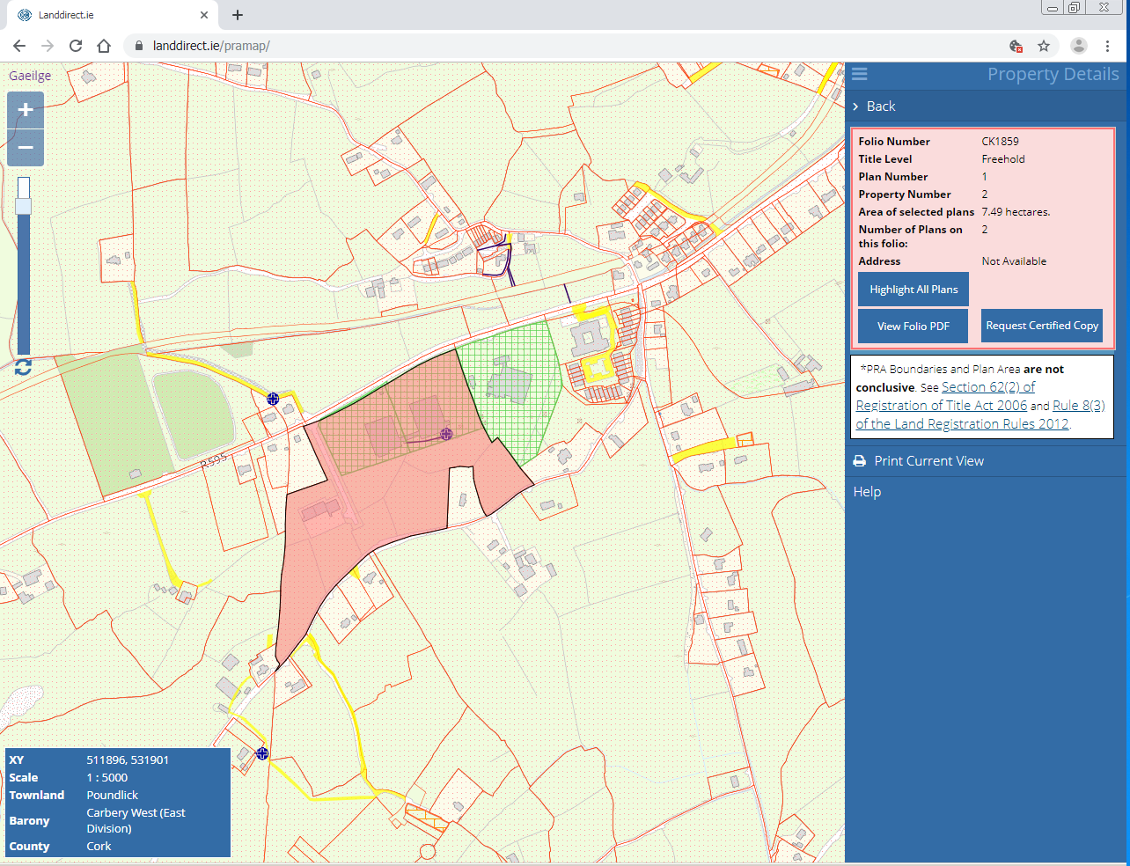

1. **Zoning Background:**

**2005 Skibbereen Local Area Plan.**

Northern portion of subject lands identified as being ‘primarily industry / enterprise’ lands.

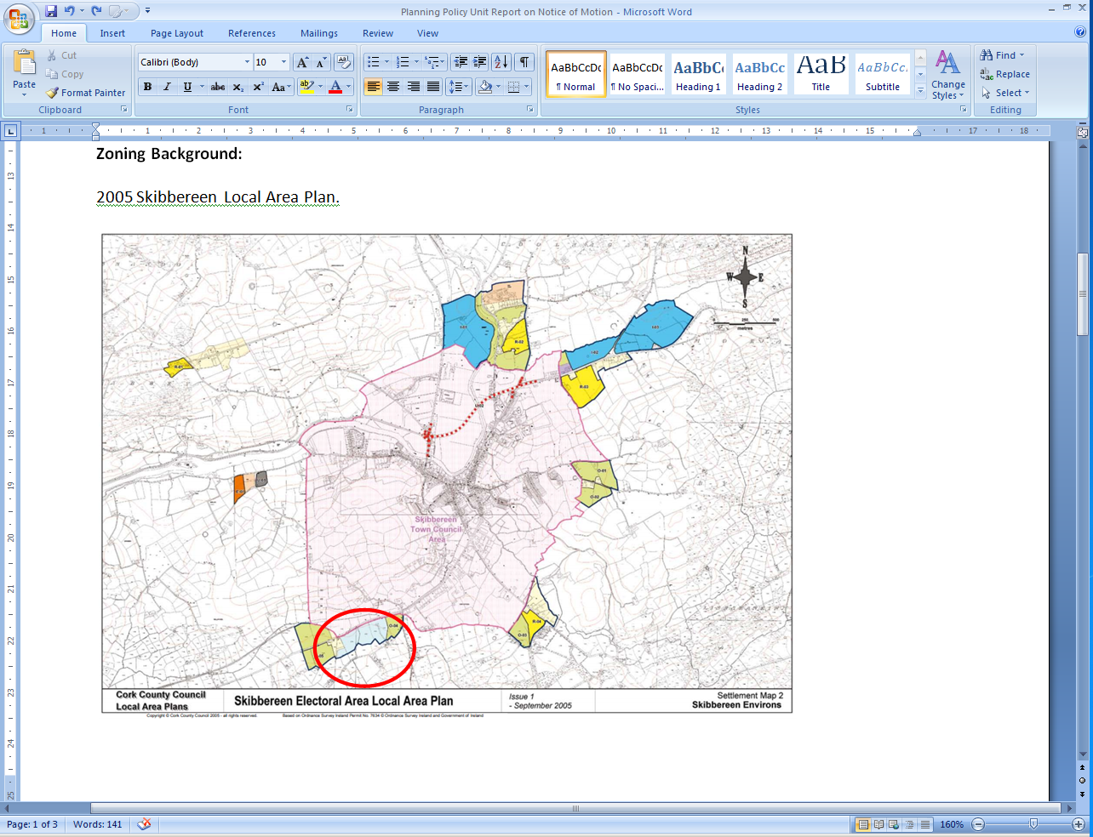

**2011 Skibbereen Local Area Plan.**

Northern portion of subject lands identified as ‘business development’ lands.

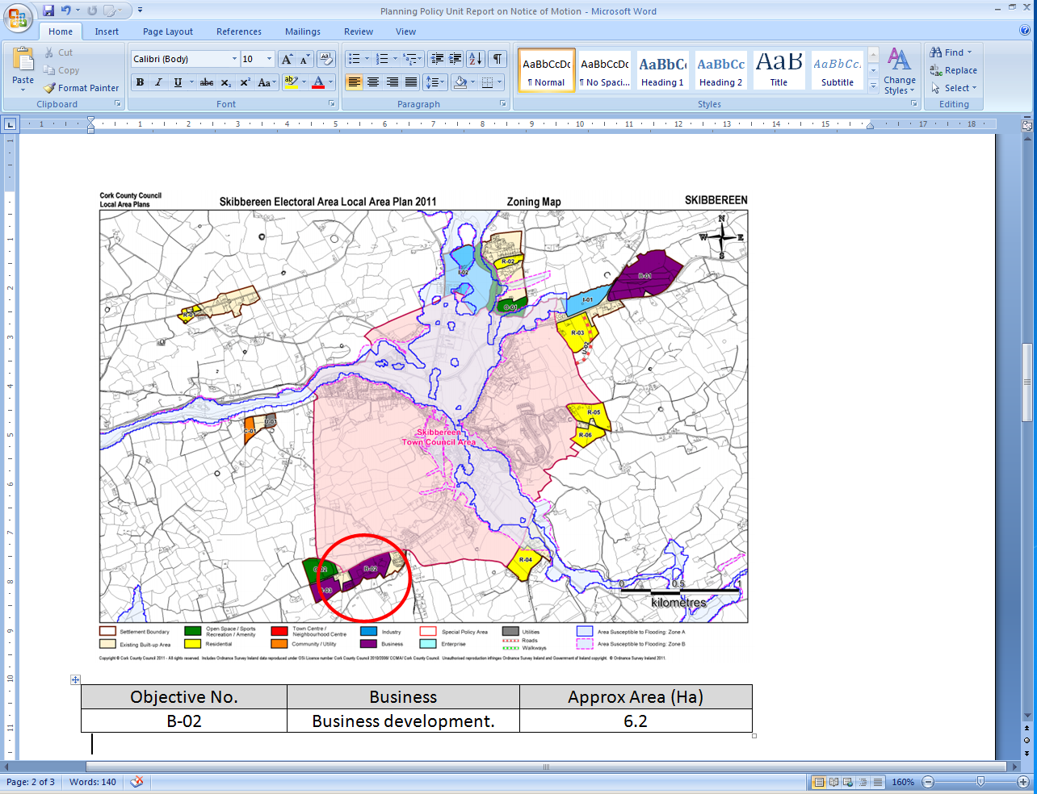

|  |  |  |
| --- | --- | --- |
| Objective No. | Business | Approx Area (Ha) |
| B-02 | Business development. | 6.2 |

**2016 Skibbereen Local Area Plan Amendment:**

Extended the ‘business lands’ zoning to the south by 3.1ha – shown hatched in map below.

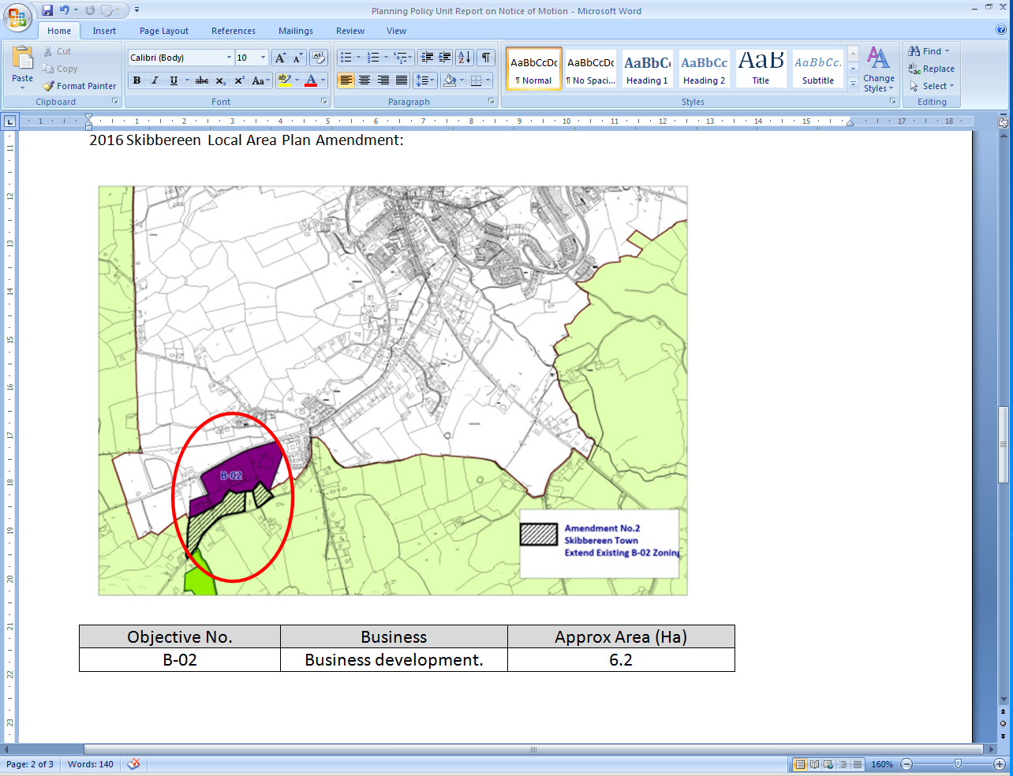

|  |  |  |
| --- | --- | --- |
| Objective No. | Business | Approx Area (Ha) |
| B-02 | Business development. | 9.3 |

Extract from Development Committee Meeting included as part of Minutes for Full Council Meeting held on April 25th 2016 – when amendment was adopted.

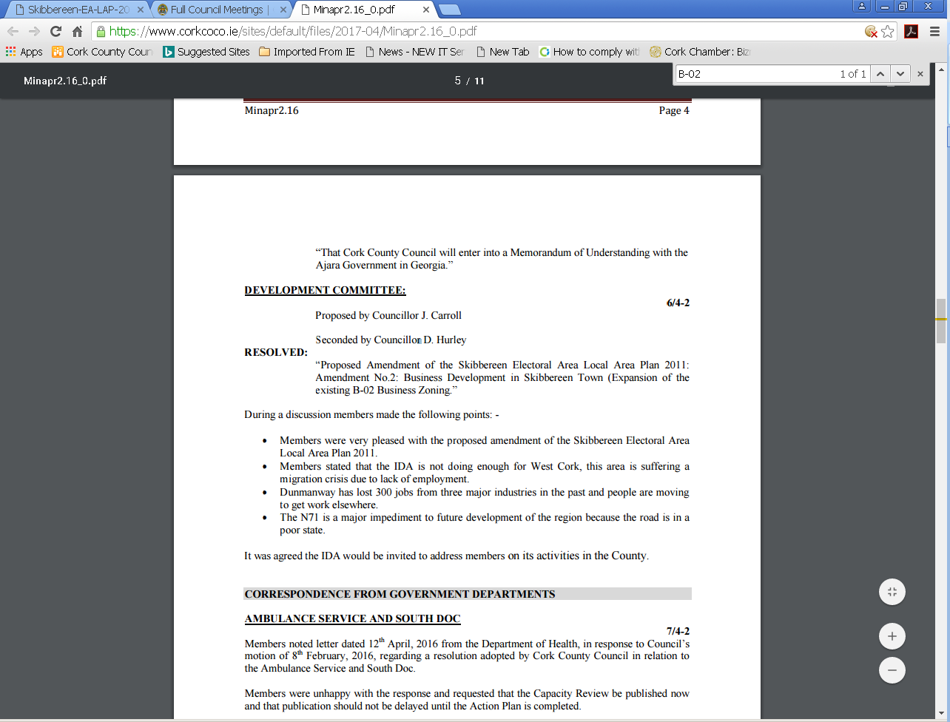

**2017 West Cork MD Local Area Plan:**

All of subject site carried forward as ‘business’ lands.

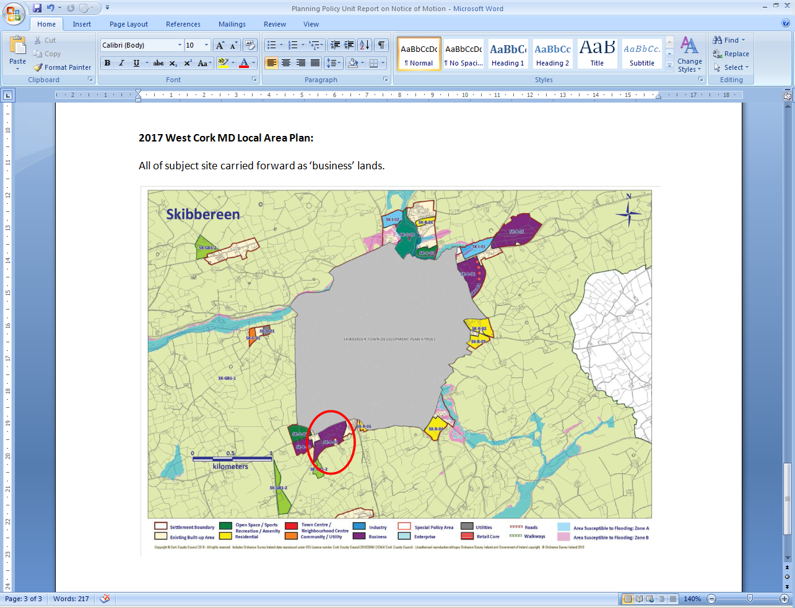

1. **Zoning Summary:**

The lands the subject of this motion are an extension of a long standing employment-related zoning. The lands were zoned for Business Development use in 2016 by LAP amendment, and, subsequently reviewed and retained as part of the 2017 MD Local Area Plan process.

During the 2016 Local Area Plan amendment process and also during the 2017 MD Local Area Plan process, no objections to the zoning of the subject lands for employment use were raised in submissions received.

As set out in the Minutes of the Development Committee where the 2016 LAP amendment was discussed, the Members expressed their support for the amendment and adopted the amendment unchanged. The Members highlighted the issue of lack of employment in the area during their consideration of the proposed amendment.

1. **Current Context:**

The following are the Business lands zonings within Skibbereen Environs:

|  |  |  |
| --- | --- | --- |
| Business Lands Skibbereen Environs | | |
| SK-B-01 | Business Development including where appropriate consideration of renewable energy projects - Flood Risk Objective Applies | 15.9ha |
| SK-B-02 | Business Development | 9.3ha (approx. 60% developed) |
| SK-B-03 | Business Development with option for a hotel/leisure centre/conference facilities | 3.5ha |
| SK-B-04 | Business Development to include provision for the Gortnaclohy Relief Road | 10.66ha |

From the above; SK-B-01 requires flood mitigation measures, SK-B-03 may be utilised for hotel/leisure related use, and, SK-B-04 requires the provision of a relief road. Therefore, SK-B-02 is considered an important element of the Business related lands to serve Skibbereen.

There is a current planning application on the subject lands as follows:

* 17/192 – current application on this site by Daly Products. Permission granted with conditions on the 19/12/17.
* PL88.300738 - A third party appeal was lodged to An Bord Pleanala. Permission granted with revised conditions on the 29/11/18.
* Following a [High Court](https://www.irishtimes.com/topics/topics-7.1213540?article=true&tag_organisation=High+Court) judicial review ruling in July 2019 the matter has been returned to the ABP to be decided in accordance with law.

1. **Requirements to Inform Proposed Amendment if Motion is Adopted:**

If the proposed Motion is adopted by Council and an Amendment proposed to the 2017 West Cork Municipal District Local Area Plan, the proposed amendment will require environmental screening and/or full environmental assessment as well as statutory consultation and reporting.

The following is required to be undertaken to progress a statutory Local Area Plan amendment:

* Notification to Environmental Protection Agency to give notice under Article 14A (4) (b) of the Planning & Development (Strategic Environmental Assessment) Regulations 2004
* Prepare Preliminary Draft of Amendment, including AA Screening Report and Environmental Report (including Strategic Floor Risk Assessment)
* Invite comments from Environmental Authorities
* Finalise Proposed Amendment Document
* Finalise AA Screening Report and Environment Report (including SFRA) for public consultation
* Publish Notice of the Proposed Amendment and invite submissions
* Send copies of plans to relevant bodies
* Proposed Amendment, SEA Environment Report and Habitats Directive Assessment Reports on display for inspection and receipt of submissions
* Publication of submissions and observations received
* Prepare a CE’s Report on any submissions or observations received, giving CE’s opinion on issues raised and submit to Members for their consideration
* Members consider CE’s Report and resolve to make, amend or revoke the proposed MD LAP amendment at Full Council Meeting.

1. **Conclusions:**
2. The proposed removal of this Business Development zoning from the current Skibbereen MDLAP without an overall assessment of the growth strategy / employment related land use zoning objectives for the Town would result in the reduction of business zoned lands in an area where there is a clear demand and need for same. The upcoming County Development Plan Review, commencing in December 2019 with the publication of Issues Papers for consultation, provides an opportunity to consider employment land needs within the County.
3. The subject lands are considered to be a suitable location, as an extension of long-standing and established employment lands.
4. Through two recent statutory zoning processes (2016 LAP amendment and 2017 MD LAP) the subject lands were considered necessary and suitable to accommodate employment uses.
5. There were no objections raised during the 2016 LAP amendment and 2017 MD LAP making processes to the use of the subject lands for Business use.
6. There is a current planning application for development on the subject lands. If the established zoning objective for the subject lands was to be amended from Business Development use to Town Greenbelt use during the period of the plan and a live planning application was submitted before said amendment was advertised and it could be demonstrated the planning application was refused permission as a result of the zoning objective amendment, depending on the specific circumstances of the case the Council could potentially be the subject of a compensation claim.

It is recommended that the matter would be dealt with during the review of the County Development Plan and Local Area Plans, this process commencing in December, 2019.

During the discussion the Members made the following points:

* Member welcomed comprehensive response
* Acknowledged the importance of potential employment to West Cork
* The Greenbelt cannot be at the expense of job opportunities
* Identified that West Cork needs sustainable sectors
* Consideration for public commuting to work every day local employment needed
* Members implied if passed would send out wrong signal that the local authority weren’t supportive of future developments
* Recommended that this should be dealt with at County Development Plan

The Mayor declared a vote was to be taken from the floor and the wording as follows: “That Cork County Council would rezone 3.1 hectares in Poundlick, Skibbereen, County Cork from B-02 Zoning back to “Town Greenbelt”, this being all the land comprised in land registry folio 1859 Cork other than the land comprised in the leases at Entry Numbers 2 and 4, Part 3 of the folio.”

**FOR: Councillor:** Cairns, O’Sullivan P, Twomey, Quaide, O’Sullivan C, Hayes Paul

**[6]**

**AGAINST:** **Councillor:** Coughlan G, Coleman, Murphy Kevin, O’Sullivan J, O’Sullivan M, O’Donovan, Collins D, McGrath, Buckley, O’Connor L, Barry, Rasmussen, O’Connor A, O’Flynn, O’Brien, O’Leary, Dawson, Roche, Moynihan B, Doyle, O’Shea J.P, Murphy Gerard, Creed, Moynihan G, Looney, Coughlan M, Hayes Pat, Murphy Gearoid, Kennedy, Madden, O’Shea T, Linehan-Foley, Collins N, O’Connor J, McCarthy S, Carroll.

**[36]**

**ABSTAIN:** **Councillor:** D’Alton, D’Alton-O’Sullivan

**[2]**

The Mayor declared results as follows 6 for, 36 against, and 2 abstentions and declared the notice of motion defeated.

**BLUE WAY:**

**15/9-1**

Councillor Danielle Twomey proposed, seconded by Councillor Noel Collins

***“That this Council would look to develop a blue way in East Cork.”***

Members noted the response from Niall Healy, Director of Services, Municipal District Operations and Rural Development which outlined as follows:

**RESPONSE:**

The Council has developed a blue way from Skibbereen to Baltimore. In North Cork, work has started on the development of a blue way from Mallow to Killavullen. In time the use of this blue way will be assessed before any decision is made to extend it further on the Blackwater River.

Failte Ireland are currently developing a new policy document on Blue Ways which will direct how they are developed into the future.

The Council’s recreational priority in East Cork is the Midleton to Youghal Greenway. There are no immediate plans to develop a blue way in East Cork.

During this discussion the Members made the following points:

* Fantastic initiative given that Cork has the largest coastline in the country.
* The creation of a blue way would complement the Youghal to Midleton greenway and is something the Council should proactively look at
* It would have major health benefits for the health and wellbeing of people
* A fantastic tourism and public amenity
* If developed would have significant impact to East Cork

Members agreed to refer this notice of motion to the East Cork Municipal District Meeting for further discussion.

**REGISTER OF ELECTORS**

**16/9-1**

Councillor Liam Madden proposed, seconded by Councillor Kevin Murphy

***“The need to have a proper system for reviewing updating and adding people to the Register of Electors.”***

Members noted the response from Patricia Liddy, Director of Services, Corporate Services which outlined as follows:

**RESPONSE:**

The onus is on individual voters to ensure that their name appears on the register and that their registration details are correct.

In order to ensure that voters can check their registration details, the draft Register is published on 1st of November each year and can be inspected during working hours at the offices of the Registration Authority or that of the County Registrar, and at all public libraries, post offices and Garda stations throughout Cork County.  It can also be checked on line at [www.checktheregister.ie](http://www.checktheregister.ie/).

The final Register is published on 1st February, and comes into force for a year on 15th February.

Elected Representatives are supplied with an electronic copy and, on request, one hard copy of both the Draft and Live version of the Register for the area they represent.

Voters who are not on the Live Register can submit an application for the Supplement in advance of a vote.

The Franchise Section of Cork County Council undertakes work to update the Register of Electors, in line with national procedures and all obligations are met with regard to the maintenance of same.  The following are some of the additional steps undertaken by Cork County Council to review the Register:

* Forms in use are supplied by the Department of Housing, Planning & Local
* Government – supplies are circulated to post offices, Garda stations, public libraries and Council offices.
* Schools are contacted to register students who turn 18.
* Issuing of renewal forms on an annual basis to Nursing Homes and Hospitals with regard to registration of new residents and removal of those who are no longer resident.
* Death Events notices are reviewed to remove voters who have passed away.
* National and local media campaigns are undertaken.

During the discussion the Members made the following points:

* Members stated that the Register of Electors system is a National issue
* Suggested automatic registration of over 18’s
* The need to automate and streamline the system
* Members requested we write to Minister Phelan to look for the publication on modification of the process

Members agreed to write to Minister of State for Local Government and Electoral Reform to request the streamlining of the Register of Electors system.

**Extension of time 2.00pm**

Proposed by Councillor Marcia D’Alton

Seconded by Councillor Kevin Murphy

**ENVIRONMENTAL PROTECTION AGENCY**

**17/9-1**

Councillor Liam Quaide proposed, seconded by Councillor Noel Collins

***“That Cork County Council would, as a matter of urgency, invite representatives of the Environmental Protection Agency to discuss air-quality monitoring throughout the Cork region in light of recent alarming reports of air pollution in congested parts of Dublin.”***

Members noted the response from Ted O’Leary, S/Director of Services, Environment & Emergency which outlined as follows:

**RESPONSE:**

If Council so decides, we can of course request the Environmental Protection Agency (EPA) to meet with elected Members to discuss air quality monitoring in Cork county. We respectfully suggest that such a meeting might be best arranged with representatives of the Environment, Climate Action & Biodiversity Strategic Policy Committee (SPC), under whose remit the development of corporate clean air policy falls.

For the information of Members the current [National Air Quality Monitoring Programme (AAMP)](https://www.epa.ie/pubs/reports/air/quality/epanationalambientprogramme.html) developed by the EPA covers the period 2017–2022.

Some Members will be aware that under this programme the Environment Directorate has been working closely with the EPA to facilitate the siting by them of monitoring stations in Cobh, Macroom and Mallow.

A Particulate Matter (PM) monitor went live in Carrignafoy, Cobh in late 2018-it’s data is available in realtime on the [EPA’s air quality webpages](https://www.epa.ie/air/quality/data/cobh/particulatematterresults/) . We are currently working with the EPA to install further monitoring equipment at a harbourside location in Cobh.

A PM monitor is also to be installed in Macroom with a traffic emission site planned for Mallow. Site selection work is well advanced in both towns and the EPA hope to have the equipment installed and operational before the end of this year.

During this discussion the Members made the following points:

* 1,500 people die every year because of poor air quality
* A need for more monitoring stations to be rolled out across the County
* Environment Protection Agency representatives need to invited in to brief Members on this issue
* Serious concerns for public health
* Lower harbour pollution needs attention

Member agreed to refer this matter for further discussion to the Environment SPC.

**LANDSCAPING SCHEME:**

**18/9-1**

Councillor Alan O’Connor proposed, seconded by Councillor Noel Collins

***“That this Council will, in its upcoming County Development Plan, include a provision whereby it is required that the landscaping schemes of all future large-scale developments in the County by comprised of locally native trees, shrubs and herbs, this being done in order to enhance the benefit of the landscaping scheme for wildlife.”***

Members noted the response from Padraig Moore, S/Director of Services Planning Department which outlined as follows:

**RESPONSE:**

As part of the Cork County Development Plan Review consideration will be given to how best to encourage the planting of native species, where appropriate, as part of landscaping schemes.   Guidance on appropriate tree/shrub species to plant around buildings is currently set out in the Councils “Cork Rural Design Guide” and in the “Making Places: a design guide for residential estate development, appendix a”.   It is also common practice to attach a landscaping condition to permissions requiring the use of native species and also to insist on native species when assessing landscaping schemes for Part 8 applications”.

During this discussion the Members made the following points:

* Members supported the creation of biodiversity culture change
* Green Infrastructure Plan should be considered for inclusion in the County Development Plan
* Resident Associations under huge pressure with cost and maintenance of elabonate planting schemes

**WATERS OF THE HARBOURS**

**19/9-1**

Councillor Noel Collins proposed, seconded by Councillor Susan McCarthy

***“That this Council request the appropriate Minister to make an order redrawing the County Boundaries to include the Waters of the harbours in which the development of either commercial or high profile nature has taken place, in order to give the Council authority to develop and control such developments.”***

Members noted the response from Padraig Moore, S/Director of Services Planning Department which outlined as follows:

**RESPONSE:**

**Marine Spatial Planning (MSP)**

* The Marine Spatial Planning EU Directive 2014/89/EU was effectively transposed into Irish law with the commencement of the [Planning and Development (Amendment) Act 2018](http://www.irishstatutebook.ie/eli/2018/act/16/enacted/en/pdf) . This new primary legislation gives effect to the requirements of the MSP Directive and establishes the necessary legal basis and broad framework for Ireland to implement MSP.
* The Department of Housing, Planning and Local Government (DHPLG) is the lead Department for Marine Planning in Ireland and the Marine Institute (MI) will support the process by providing the necessary technical and scientific advice.
* The Department (DHPLG) will manage the preparation of a Draft National Marine Planning Framework which is due to be published in the coming months with a period of extensive public consultation.
* This plan will apply from the High Water Mark in Ireland’s coastal waters, territorial seas, exclusive economic zone and in designated parts of the continental shelf.
* Marine planning will contribute to the effective management of marine activities and more sustainable use of our marine resources/
* The Department (DHPLG) will prepare any legislation and policy guidance that is required, including the preparation of the Marine Planning and Development Management Bill.   
  It is intended that once the final iteration of the scheme is produced (end September 2019) that a formal public and stakeholder engagement process will commence which will inform the drafting of the legal text.

During the discussion the Members made the following points:

* Members requested rivers, harbours and lakes be included in the upcoming County Development Plan
* Certain areas of coastline should be in the remit of the local authority
* Local Authority would extend number of kilometres out in to sea

Members agreed to write to the Minister to get an update on the draft National Marine Planning Framework.

**BOOK RENTAL SCHEME**

**20/9-1**

Councillor Audrey Buckley proposed, seconded by Councillor Gearóid Murphy

***“In view of the rising cost for school books, both to primary and secondary schools, I would ask that Cork County Council write to the Minister of Education and demand that the promised revised costs of school uniforms and books be implemented as promised by Minister Bruton in April 2018. Simple steps that can be implemented – Mandatory Book Rental Schemes, Books with binders to add the new material, this would stop the increasing costs of requiring a parent to buy the whole book again. The average cost of primary school books is €110 and secondary €320. With the older edition books been discarded, we should be setting an example in the fight for our Climate Change Adaption Plan.”***

During this discussion the Members made the following points:

* Cost of books & uniforms are very expensive
* A book rental scheme should be implemented to prevent huge costs
* A review at Ministerial level is needed urgently Financial incentives are also needed

Members agreed to write to the Minister to introduce financial incentives to schools who introduce book rental schemes and uniform reuse.

**GARDA PERSONNEL**

**21/9-1**

Councillor Ben Dalton O’Sullivan proposed, seconded by Councillor Seamus McGrath

***“In view of the apparent decline in the number of Garda personnel across the County Cork area, that Cork County Council would write to the Minister for Justice and the Gardaí Commissioner to request that a delegation of members would meet with them to discuss the urgent need for more Garda personnel to be assigned to the County Cork area.”***

During this discussion the Members made the following points:

* The Carrigaline area is not operating a full time Garda Station
* There is a huge increase in Anti Social behaviour and gangland crime
* Allocation of Garda personnel urgently required across County Cork
* Text alerts and social media sites are of a huge advantage to local communities but still need bodies on the ground

Member agreed to write to the Garda Commissioner and Minister of Justice to request that a delegation of Members would meet with Members to discuss the urgent need for more Garda to be assigned to County Cork.

**SCHOOL BUS TRANSPORT**

**22/9-1**

Councillor Frank O’Flynn proposed, seconded by Councillor Gearóid Murphy

***”That Cork County Council would call on Mr. John Halligan TD Minister of State for Training and Skills to review the School Bus Transport Service in light of the many issues and difficulties experience by families and students to access the School Transport Service for 2019/2020 school year.”***

During this discussion the Members made the following points:

* Stressful for families and children due to lack of transport resources
* Bus school transport should work with schools to allocate tickets to pupils
* Increase size of buses to accommodate more students
* School numbers are increasing and the matter will get worse if it’s not addressed urgently

Members agreed to write to the Minister to review the School Bus Transport Services and provide more funding.

**ROAD SAFETY AUTHORITY**

**23/9-1**

Councillor Seamus McGrath proposed, seconded by Councillor Kevin Murphy

***“This Council requests that the Road Safety Authority actively engage with Sat Nav providers to ensure that suitable routes are recommended from a safety perspective. Directing drivers to use local roads, instead of regional and national roads, is very often inappropriate when prior knowledge/experience of the road conditions is not available, this is particularly in case with regard to HGV’s.”***

During this discussion the Members made the following points:

* Software update need to be prioritised
* Sat Nav providers need to differentiate between HGV’s and Car routes
* Town and village residents concerned with traffic congestion because of unsuitable routes provided
* Avoid town/village centres from a traffic and environment point of view

Members agreed to write to the Road Safety Authority looking to prioritise software updates.

**UNIFORM REUSE AND BOOK RENTAL SCHEMES**

**24/9-1**

Councillor Marcia D’Alton proposed, seconded by Councillor Martin Coughlan

***“That the Department of Education would provide financial incentives to schools or Parents Associations of schools (both primary and secondary) who run uniform reuse programmes and book rental schemes.”***

During this discussion the Members made the following points:

* Incentives for the reuse of books and uniforms should be implemented
* The introduction of a reusable scheme would make education more accessible and limit cost
* Weight of school books also an issue for children as they cannot walk or drive to school

Members agreed to write to the Minister to set up incentives to schools who introduce book rental schemes and uniform reuse scheme.

**VOTES OF CONGRATULATIONS**

**25/9-1**

**TO:** Ballygarvan Agricultural Show on the successful organization of the annual agricultural show

**TO:** Five Mile and District Vintage Club on the successful organization of the Aaron O’Leary Memorial Run

**TO:** Jamie Flannery – On winning Rose of Tralee Escort of the year

**TO:** Bantry Blues Junior B Hurling on winning Cork South West Junior B Hurling Championship

**TO:** Castletownroche G.A.A on winning Cork County 2019 Junior B Hurling Championship

**TO:** Jack Lawton on winning a Minor All-Ireland Football Medal

**TO:** Ryan O’Donovan on winning a Minor All-Ireland Football Medal

**TO:** Katie O’Keeffe on winning silver medal in the European Championships for boxing recently

**TO:** Nora Ann Cassidy on recently being inducted into the Michigan Irish American Hall of Fame

**TO:** Patrick J. Johnson on recently being inducted into the Michigan Irish American Hall of Fame

**TO:** Fionn Ferriera on winning Google Science Fair winner

**TO:** James O’Regan on winning an All-Ireland Minor Football medal

**TO:** Keith O’Driscoll on winning an All-Ireland Minor Football Medal

**TO:** Conor Corbett on winning an All-Ireland Minor Football 2019 medal as Captain of the Cork team

**TO:** Francis McEveney & Committee on the success of the Passage West Ladies Football Blitz 2019

**TO:** Passage West Karate Club on retaining the ‘Best Club Award’ at the I.J.K.A. Munster Open Championships 2019

**TO:** Queen of the Sea Festival Committee and to all involved in organising a very successful event 2019

**TO:** Youghal for All on winning the 96FM ‘Festival of the Year’ 2019

**TO:** Youghal Medieval Festival and to all involved in organising a very successful event 2019

**TO:** Ciarán O’Sullivan on winning an All-Ireland Minor Football 2019 medal with the Cork team

**TO:** Michael O’Neill on winning an All-Ireland Minor Football 2019 medal with the Cork team

**ANY OTHER BUSINESS**

**OPENING OF TENDERS:**

The following tenders were opened at the meeting:-

1. The construction of new sea wall and footpath at Market Place, Youghal.
2. The TII VRS Programme 2019 Call off No. 1 for County Cork.

**This concluded the business of the Meeting**