

**BANDON KINSALE**

**MUNICIPAL DISTRICT (INCLUDING VILLAGES)**

Streetscape Painting, Signage

& Improvement Scheme 2024



**Streetscape Painting, Signage &Improvement Scheme 2024**

Cork County Council is pleased to announce the following schemes for 2024:

1. Tenants or owners of buildings can avail of a grant of up to 50% of the full cost of painting the facades along the street which may include paint, labour, scaffold/ hoist and other materials etc. **Priority will be given to full facade** i.e. shop fronts and overhead. **Two quotations from registered painting contractors will be required.**
2. Applications on a full street basis (10 or more adjacent buildings on one street) will be prioritised over individual applications. If a full street comes together a grant of 60% will be provided.
3. Tenants or owners of buildings in the Town Centre can avail of a grant of up to 50% of the costs of replacing existing plastic, neon & printed signs etc. with ‘‘Heritage Type Signs’’.
4. A contribution to a maximum of 100% will be paid towards the cost of materials where it is proposed the tenant/owner will undertake the works themselves. If availing of grant for materials only, the attached disclaimer form must be completed and returned. **One quotation only for materials will suffice.**

**The following steps need to be taken to qualify for the Painting and Signage Grants:**

* Make a formal application in writing to Bandon Kinsale Municipal District Offices, Town Hall, Kinsale of Cork County Council providing the following information:

1. **Good quality** photographs of the building’s present condition/current signage arrangement.
2. Include quotations as applicable (see No. 1 & 2 above)
3. Proposed colour scheme. Cork County Council may engage a colourist who has created a colour palette for the streetscape and the indicated colour for use will be detailed on your letter of offer.
4. Details of the proposed new signage. The proposed signs should be ‘‘Heritage Type Signs, approved by CCC’’ of wood or wood/cast metal construction and painted. Plastic, sheet metal, neon etc. will not be considered. **One quotation** from the sign manufacturer will be required. As appropriate the Municipal District may refer signage proposals to the Heritage Officer for comment/sanction.
5. Where a scaffold/hoist is required a permit must be sought in advance from Cork County Council at a cost of €125 per month.

* Where works are undertaken without the prior written approval of CCC, a grant **will not be awarded** to the applicant. On completion of works, the Council are to be notified so that an inspection can be arranged. Works must be completed within 4 months of the date of approval.
* Please note if works are not complete by 31st October 2023 the grant will lapse.
* If the scheme is *oversubscribed* the applicants eligible to continue in the application process will be selected by what is ***considered by the Council to be the highest need***.
* Where a contractor is appointed **it shall be the responsibility of the successful applicants to ensure** that all necessary consents are obtained and all relevant legislation and codes of practice, in particular those related to Health & Safety which apply to such work and / or approved schemes, are complied with.
* The Contractor is to submit relevant invoices to the applicant who in turn submits the invoice and receipts to the Council for inspection, approval and payment of funds.
* If applying for cost of materials only, the applicant must complete the attached disclaimer from and submit with the application form.
* Please note a valid application does not guarantee funding.
* Local Authority Charges due by applicants must be paid up to date.
* Photographs of approved properties may be used in future promotions of the Streetscape Painting and Signage Scheme.

**Please note that the Contract is between the applicant and the painting contractor/sign manufacturer.**

**Applications should be submitted to: Bandon Kinsale Municipal District, Town Hall, Kinsale, Co. Cork or** [**bandonkinsalemd@corkcoco.ie**](mailto:bandonkinsalemd@corkcoco.ie)

**The Council’s adjudication on the validity of any application for this scheme and any grant sum to be allocated on foot of an application shall be final.**

**CLOSING DATE FOR RECEIPT OF APPLICATIONS IS FRIDAY 14th June 2024**

**(Please see application form overleaf)**

***Application Form***

**Applicants Name & Address:**

**(Please specify building owners name if different)**

**................................................................................................................................................................................................................................................**

**................................................................................................................................................................................................................................................**

**Tel No: _______________________________**

**Mobile No: _______________________________________**

**Email: ______________________________________________**

**Address of Premises to be upgraded:**

**................................................................................................................................................................................................................................................**

**...............................................................................................................................................................................................................................................**

**I agree to the colour proposed by the colourist / Cork County Council: YES/NO**

**Contractors / Material Quotation (include VAT in Total) _____________________**

**Tax Reference Number of Contractor (if applicable) _____________________**

**Tax Reference Number of Applicant or PPSN for individual______________________**

**CHECKLIST:**

* **Before pictures – good quality.**
* **Completed Application Form.**
* **2 x Painting Contractors Quotations (Include VAT in total).**
* **1 x Materials Quotation.**
* **Completed Bank Account Details Form.**
* **Completed Disclaimer Form where applicant intends to paint property themselves.**



**Streetscape Painting, Signage &Improvement Scheme 2024**

**DISCLAIMER AGREEMENT**

This agreement is entered into between Cork County Council and the applicant

___________________________________________________________________________

on the __________ day of ______________ 2024 for the purposes of the 2024 Streetscape,

Painting, and Signage &Improvement Scheme

Payment of grant (as advised) will be due in full upon completion of the work.

Any variations to the work following the allocation of the grant and prior to commencement of work must be agreed with the Council as soon as possible.

**Liability**

The applicant will be held liable for the extent of works carried out and on behalf of the applicant. No liability shall be accepted in respect of works by Cork County Council. The Council shall not be held responsible for any loss or damage to property, materials or injuries to individuals caused by the personal actions of the applicant or the person(s) undertaking the works on their behalf before, during or after such works have been carried out.

**Health and Safety**

The applicant will take appropriate and practical measures to ensure the environment in which works are being carried out is safe to avoid risk of injury to themselves, and/or other parties. The Council accepts no liability for the actions of the applicant or their appointed contractor which result in damage or injury to persons or property.

Please note that the Contract is between the applicant and the painting contractor/sign manufacturer.

Signature

**Appendix 1**

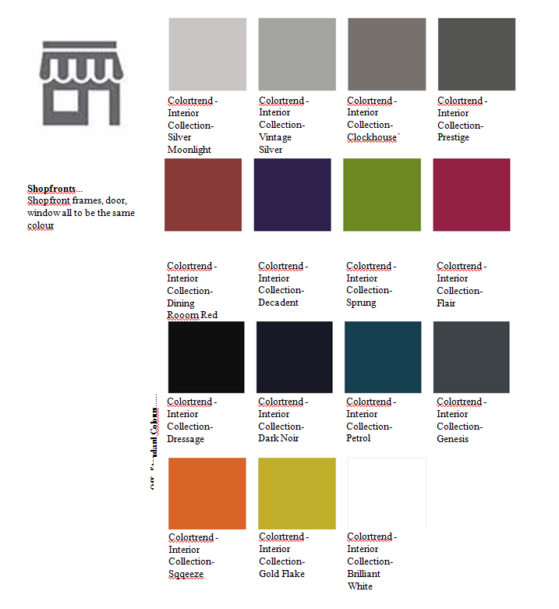

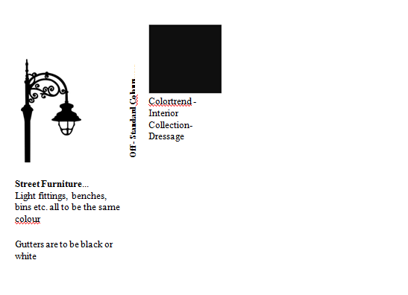

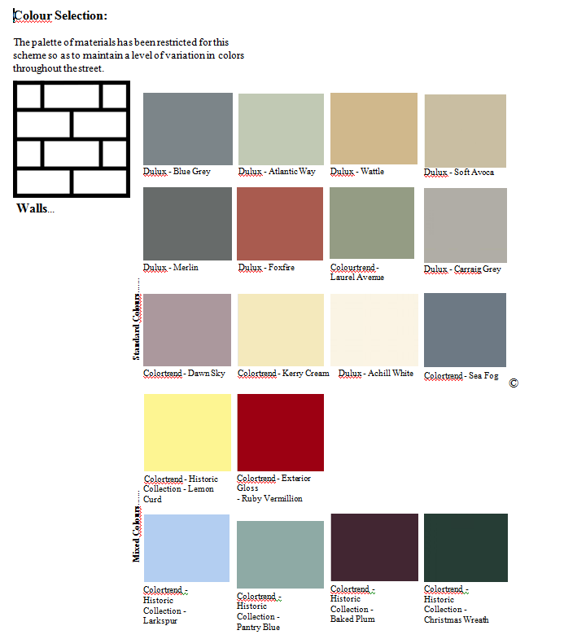

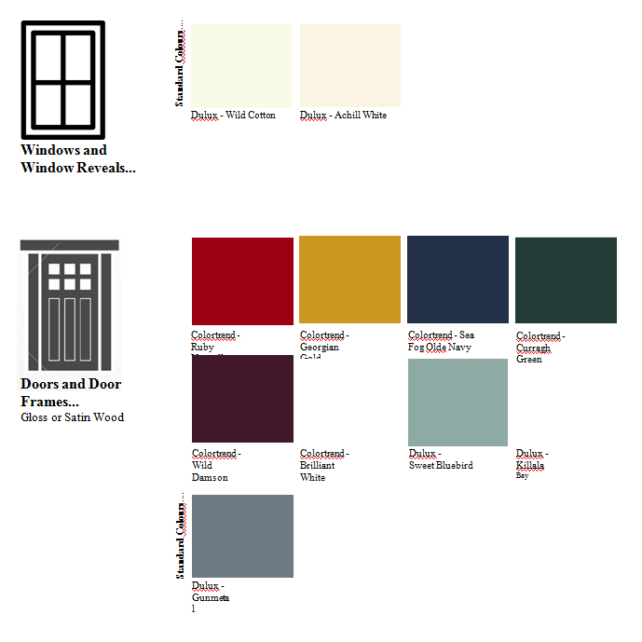

# Cork County Council

# 

## Bank Account Details

**Supplier Name/Address Supplier Number** ________________

____________________

____________________

____________________

Telephone Number: ________________________

Fax Number: ________________________

E-mail Address: _____________________________________________________

*Please note that it is Cork County Council policy to e-mail remittance advices.*

*Please supply one company address for your accounts section (less that 40 characters).*

*Please* ***get your bank to stamp*** *their official stamp in this box to verify sort code and account number* ***before you return this form***

Supplier Contact Name___________________________

Name of Bank: ____________________________________________

Branch Address: ____________________________________________

____________________________________________

____________________________________________

Name(s) of Account Holder(s): _________________________________

**OFFICIAL BANK STAMP REQUIRED**

Branch Sorting Code:

BIC NUMBER

Account Number:

|  |  |  |  |  |  |  |  |  |  |  |  |  |  |  |  |  |  |  |  |  |  |
| --- | --- | --- | --- | --- | --- | --- | --- | --- | --- | --- | --- | --- | --- | --- | --- | --- | --- | --- | --- | --- | --- |
|  |  |  |  |  |  |  |  |  |  |  |  |  |  |  |  |  |  |  |  |  |  |

IBAN NO:

Signature of Account Holder_________________________________

Position Held: ____________________________________________

Date: ___________________________________________________